Dewcis Solutions
Installation of CentOS
CentOS Installation Guide

DewCis Solutions LTD
5/29/2013

Table of Contents
The installation process: 3
Installing postgres: 8
What is postgresql? 8
Install pgadmin tools: 9
Important commands to note: 10
iReport 11

The installation process:
First and foremost, back up any existing data or documents on the hard disk where you plan to install, or format the machine where need be.

The installation starts with the detection of the CentOS installer from the DVD. It is important to note that in case you want to abort the installation process at any time before the Installing Packages screen, either press Ctrl+Alt+Del or power off the computer with the power switch.
This ensures that CentOS makes no changes to your computer until package installation begins.

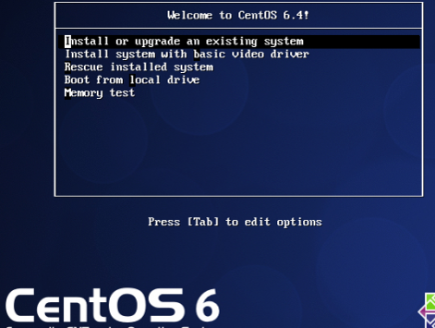

- There is an option to test media once the CD/DVD starts, we skip this because it can take unnecessarily long.
- Select preferred language
- Partitioning the Hard Disk

If you are installing CentOS and you get this question on a fresh system, “Would you like to initialize this drive, erasing ALL DATA?'', then answer 'Yes'.
If otherwise, answer 'No'. This is in case one wants to either install the OS on a partition or or the whole system.
The computer can use more than one OS if you choose to partition the disk.

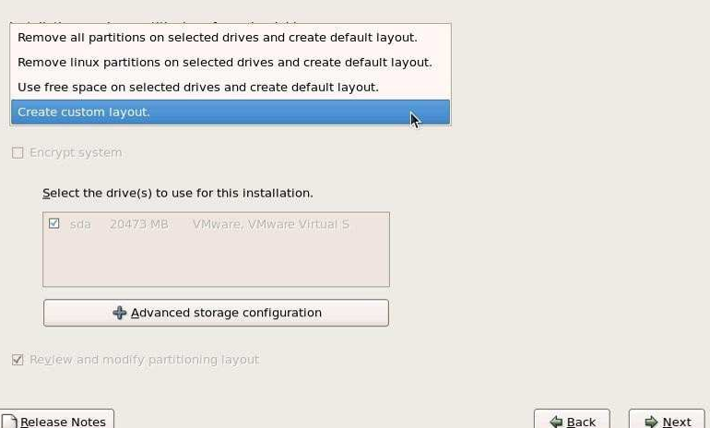

Next step is to select a partition schema for our installation. CentOS provides these four options as listed below-

- Remove all partitions on selected drives and create default layout
- Remove Linux partitions on selected drive and Create default layout
- Use free space on selected drives and create default layout
- Create custom layout

Choose ‘Create Custom Layout’ from the drop down available and Click next to continue. This helps to customize the necessary set of partitions.

Choose the Boot partition (/boot from the Mount Point Drop down) and specify the size of the partition and click Ok to continue.
The screen will look like this;

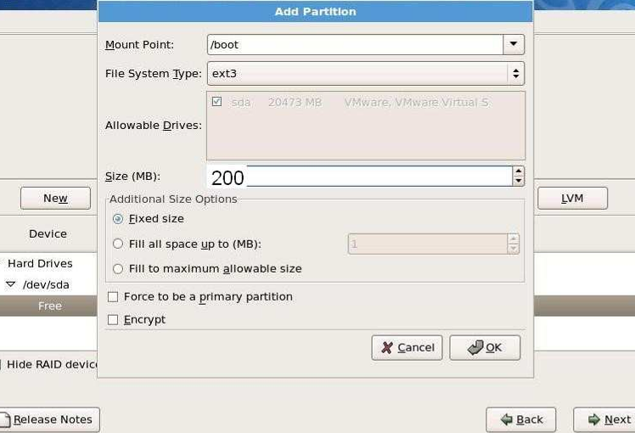

Choose /home from the drop down and give the size of /home partition and then click Ok to Continue

Choose /var from the drop down and give the size of /var partition and then click Ok to Continue

Choose /tmp from the drop down and give the size of /tmp partition and then click Ok to Continue.

Choose /usr from the drop down and give the size of /usr partition and then click Ok to Continue

Choose /opt from the drop down and give the size of /opt partition and then click Ok to Continue

Choose File System Type as swap from the drop down and give the size of the swap partition* and then click Ok to Continue.

Choose / from the drop down and choose ‘Fill to maximum allowable size’ and then click Ok to Continue.

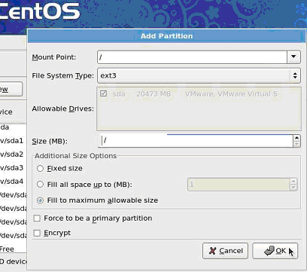

If there are no more changes, click Next to Continue

The next step is to install the GRUB loader, enter a boot loader password.

GRUB (GRand Unified Bootloader) is a program that installs a boot loader to the Master Boot Record (MBR), which exists at the beginning sectors of a disk. It allows you to place specific instructions in the MBR that loads a GRUB menu or command environment, permitting you to start the operating system of your choice, pass special instructions to kernels when they boot, or discover system parameters (such as available RAM) before booting.
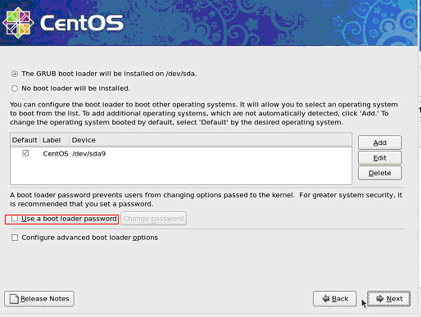

The next step is the Network Configuration.

This detects hardware in the network and configures it with DCHP.

We are installing a server so we assign an IP address. Click the 'Edit' button on the right, disable use dynamic IP configuration and enable IPv4, giving your network card static IP address, eg 192.67.100.10 and a suitable network mask eg 255.255.255.0.

Set the hostname manually, e.g. server1.example.com, and enter a gateway (e.g. 192.168.0.1) and up to two DNS servers (e.g. 213.191.92.86 and 145.253.2.75). Once this is complete, network Configuration is complete.

Set up the system clock in your time zone.

Set up a root account; this makes you the 'super user'. Give it a strong password containing alpha-numeric and special characters. It is important to note that the super user has all the privileges in the system use.

Also note the importance of strong passwords; if any other user has access to this account, and deliberately or accidentally makes changes, they are not reversible. This means that if something is deleted, then it cannot be recovered.

Next step is installing the packages.
- Select Desktop –Gnome Desktop Environment
- Application - Editors, Graphical Internet (For messaging and web servers)
- Servers –Server Configuration Tool
- Base System –Administration Tools, Base, X-Window System and click on

The installer then checks the dependencies of the selected packages.

You can install any extra packages required for your environment such as postfix for email notifications or SNMP support, Base system, Base, Compatibility libraries, Debugging tools, Hardware monitoring utilities, Large systems performance, Servers, Server platform, Databases, MySQL Database client,
MySQLdatabase server

Once you click next, the install will continue to the end, the reboot the system.
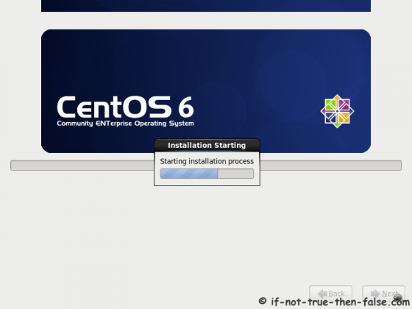
If you are using CD images or have selected packages that reside on disk 2 of the DVD image, you will need to swap a disk or two before the install is completed. Once the server has rebooted, there are a couple of post install tasks.

1. system-config-network. Use this tool to enter the server’s network configuration.

2. yum –y update. This will fully update the system to the latest package versions, either from the internet mirrors or the library in case they have been stored in the library.

Next is the installation of CentOS with chosen packages, which takes a while, but once its complete remove the installation CD/DVD and reboot your computer.

Installing postgres:

What is postgresql?

PostgreSQL is an open source object-relational database system which has sophisticated features such as Multi-Version Concurrency Control (MVCC), point in time recovery, tablespaces, asynchronous replication, nested transactions (savepoints), online/hot backups, a sophisticated query planner/optimizer, and write ahead logging for fault tolerance. It supports international character sets, multibyte character encodings, Unicode, and it is locale-aware for sorting, case-sensitivity, and formatting.

PostgreSQL provides an alternative to MySQL for running database applications. Many popular applications today have support for both. The (dv) Dedicated-Virtual Server includes MySQL 5. However, PostgreSQL support is not included.
Download the pgAdmin packages from the internet.
The command for installing postgresql:-
(eg 9.2)- postgresql92 postgresql92-server postgresql92-contrib
To install a basic PostgreSQL 9.1 server:
yum install postgresql91-server
The command for listing available packages:
yum list postgres*
Package names in the PostgreSQL yum repository follows the same standard as the ones included in the main repositories, but include the version number, such as:
- postgresql91
- postgresql91-server
- postgresql91-contrib
- pgadmin3_91

Initialize
The first command (only needed once) is to initialize the database in PGDATA:
service <name> initdb
Startup
If you want PostgreSQL to start automatically when the OS starts: chkconfig <name> on, and to remove everything:yum erase postgresql91*

Install pgadmin tools:
pgAdmin is a comprehensive design and management interface for PostgreSQL database, designed to run on most operating systems. The software is written in C++ and uses the excellent wxWidgets cross platform toolkit. In every environment, pgAdmin is a native application. The application is executed in binary code, not in a virtual machine, therefore offering excellent performance.

The pages in this section of the website should provide you with all the information you need to get started as a new developer, including GIT access, the developers mailing list, the Development Team structure, the TODO list and the change log.

pgAdmin is designed to answer the needs of all users, from writing simple SQL queries to developing complex databases. The graphical interface supports all PostgreSQL features and makes administration easy. The application also includes a syntax highlighting SQL editor, a server-side code editor, an SQL/batch/shell job scheduling agent, support for the Slony-I replication engine and much more. Server connection may be made using TCP/IP or Unix Domain Sockets (on *nix platforms), and may be SSL encrypted for security. No additional drivers are required to communicate with the database server.
pgAdmin is developed by a community of PostgreSQL experts around the world and is available in more than a dozen languages. It is Free Software released under the PostgreSQL License.
The main window for pgAdmin 3 looks like this:
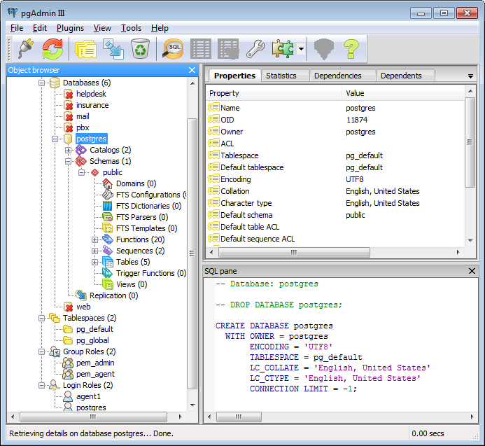

Important commands to note:
su root
This makes you the super user.
To be able to install packages or add any software to your OS, you need to be the ‘superuser'. To be able to do this, change user to root
chmod 777- this is a read, write, and execute command, it allows you all privileges.
To get all privileges for any change or upgrade, you use
initdb- this command 'initializes database'. It creates a new a collection of databases (in postgresql) that are managed by a single server instance
To edit files use 'gedit' command
pg_hba- this command checks available connections and configures all possible IPs that can connect to the database.

iReport
iReport allows users to generate user configurable reports in various formats (xls, pdf, doc etc).

